**EN 3160 Image processing a Computer Vision Assignment 2**

**Index no: 200356A**

**Question 1**

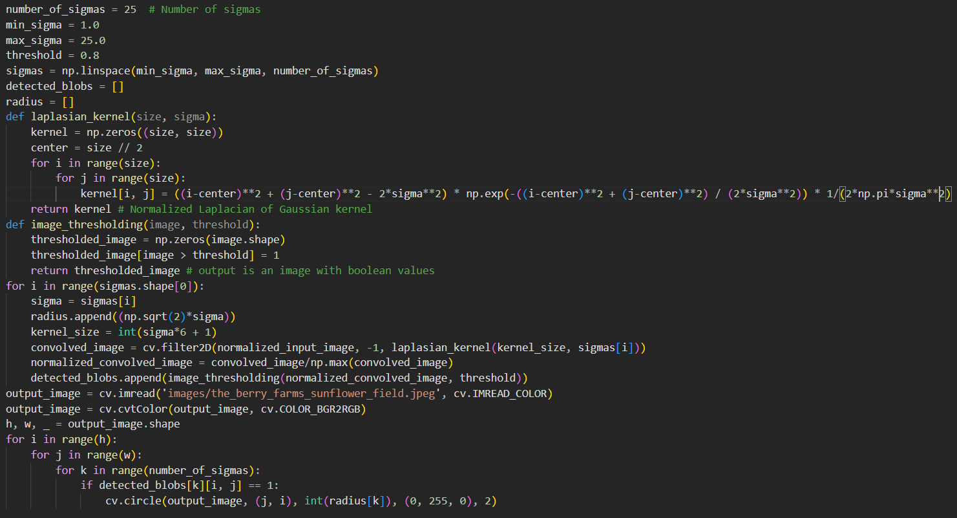

Location and Radius of max blob

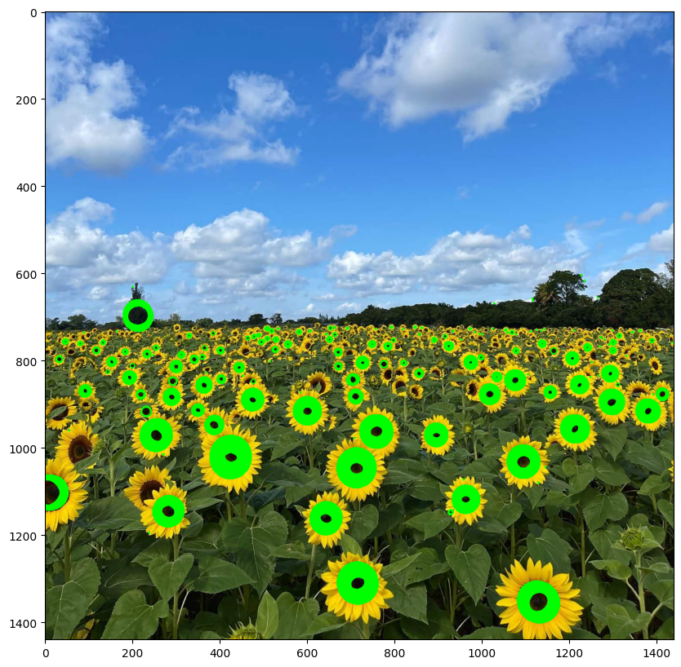

**Question 2**

Best RANSAC Line a, b, d, and inliners values are

best model found: [2.1893539 3.16277678 9.85943152] , no of inliners = 46

Best RANSAC Circle x center, y Center, and radius are

RANSAC circle: [2.1893539 3.16277678 9.85943152]

If we tried to find the circle first, circle might be very large to fit the points of the line to the circumference. Therefore, more convenient method is to find the RANSAC line first and then take the RANSAC circle.

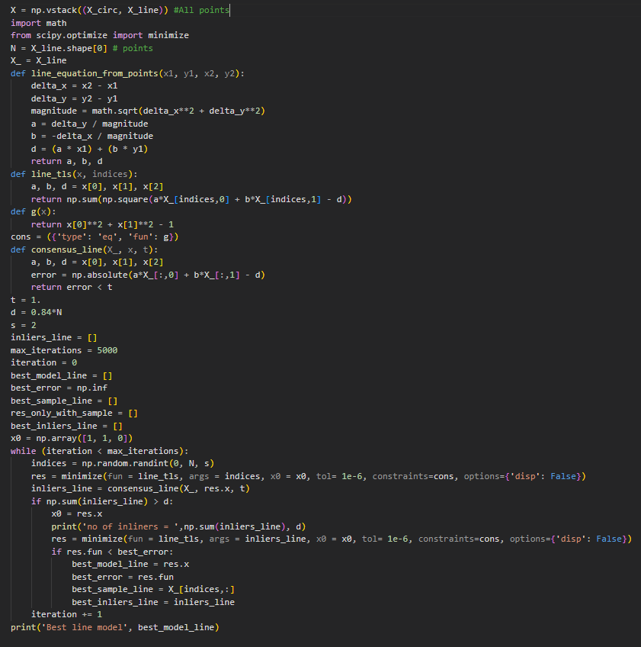

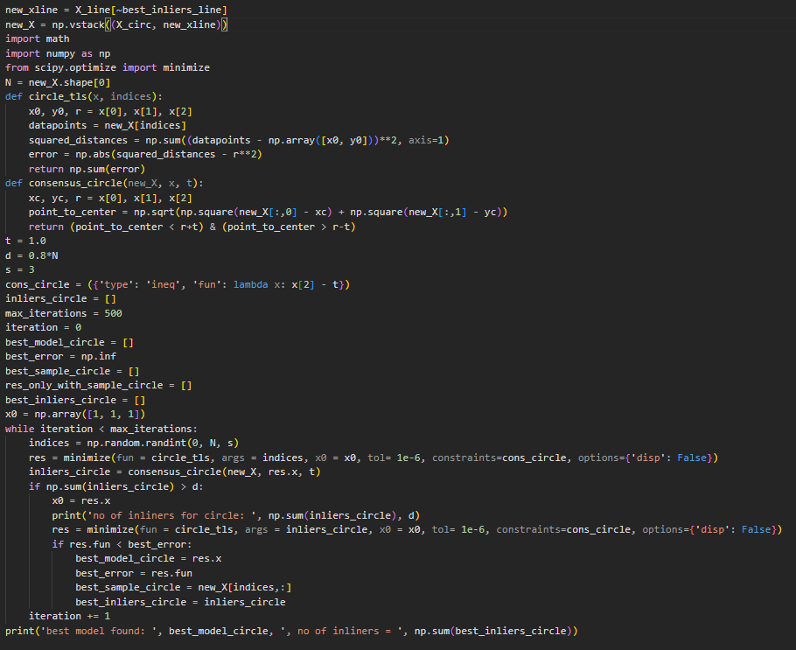

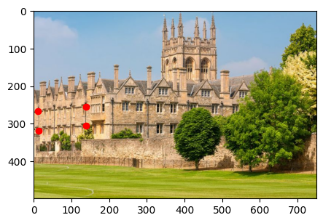**Question 3**

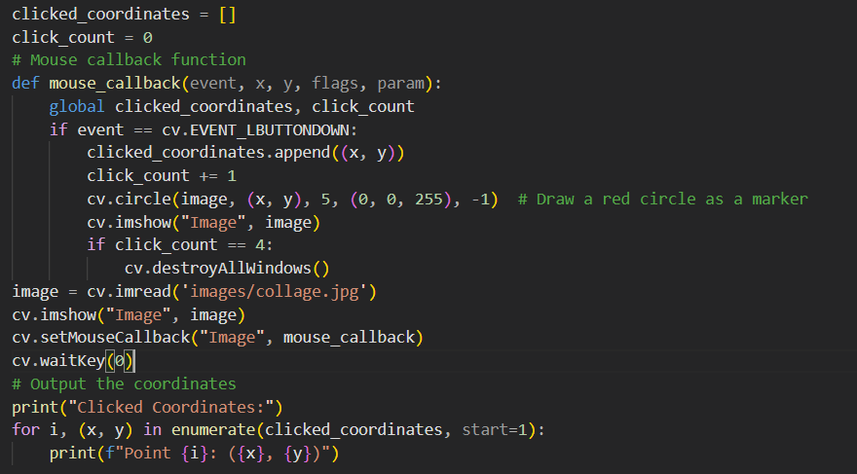

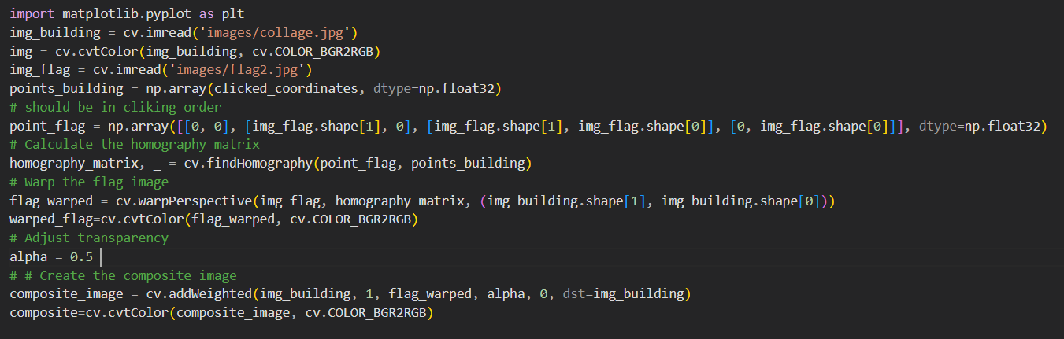

**Question 04**

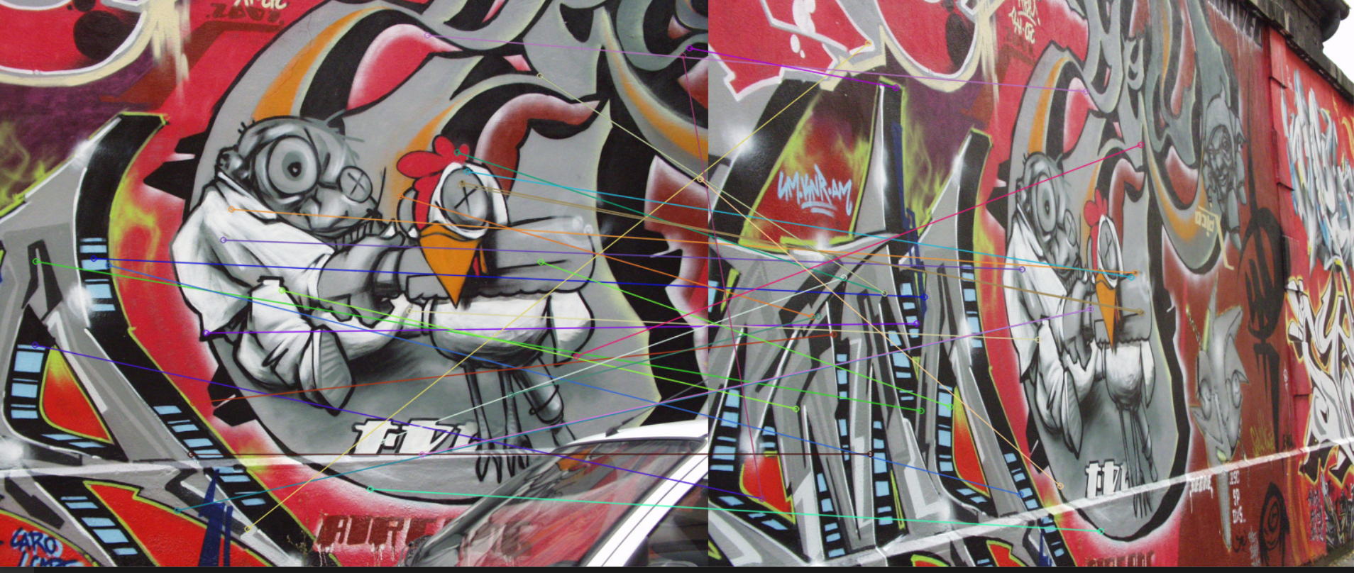

Github link - <https://github.com/Dulan24/S5_EN3061_Image-processing/tree/master/Activity%2002>